**Hypothesis Testing (T-test)**

**INPUT**

test1<-c(20,30,50,40,30,20,50,40,30)

test2<-c(30,40,60,50,40,30,60,50,40)

t.test(test1,test2,alternative="two.sided",var.equal=FALSE)

**OUTPUT**

test1<-c(20,30,50,40,30,20,50,40,30)

test2<-c(30,40,60,50,40,30,60,50,40)

t.test(test1,test2,alternative="two.sided",var.equal=FALSE)

Welch Two Sample t-test

data: test1 and test2

t = -1.8766, df = 16, p-value = 0.07893

alternative hypothesis: true difference in means is not equal to 0

95 percent confidence interval:

-21.296343 1.296343

sample estimates:

mean of x mean of y

34.44444 44.44444

**INPUT**

test1<-c(30,40,60,50,40,30,60,50,40)

test2<-c(20,30,50,40,30,20,50,40,30)

t.test(test1,test2,alternative="two.sided",var.equal=FALSE)

**OUTPUT**

>test1<-c(30,40,60,50,40,30,60,50,40)

test2<-c(20,30,50,40,30,20,50,40,30)

t.test(test1,test2,alternative="two.sided",var.equal=FALSE)

Welch Two Sample t-test

data: test1 and test2

t = 1.8766, df = 16, p-value = 0.07893

alternative hypothesis: true difference in means is not equal to 0

95 percent confidence interval:

-1.296343 21.296343

sample estimates:

mean of x mean of y

44.44444 34.44444

**Chi-square test and T test**

**Import dataset survey**

library(MASS)

survey

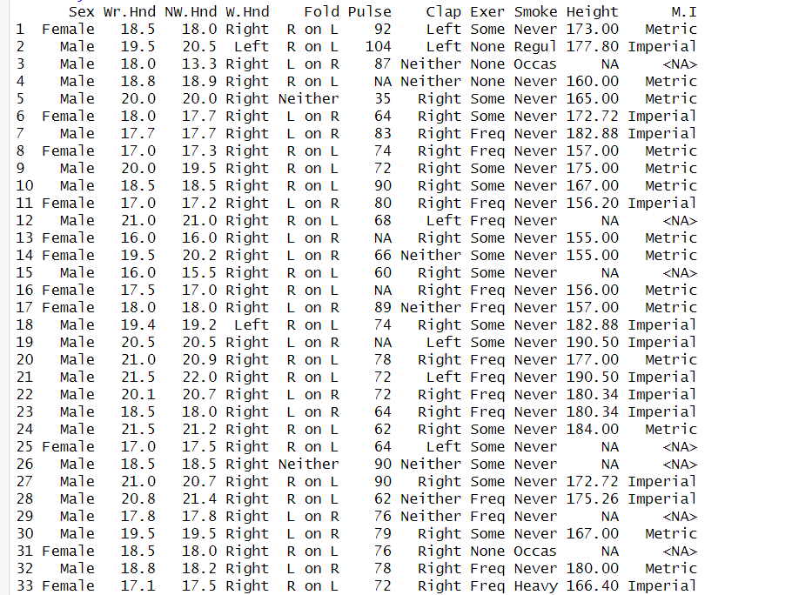

**Choose only two column and print them**

sample<-data.frame(survey$Smoke,survey$Exer)

sample

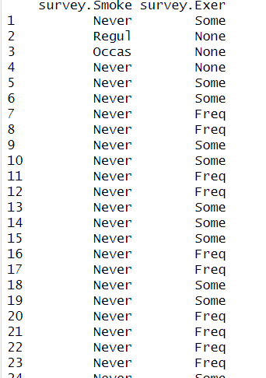

**Create contigency table and print them**

Stable<-table(survey$Smoke,survey$Exer)

Stable

Freq None Some

Heavy 7 1 3

Never 87 18 84

Occas 12 3 4

Regul 9 1 7

Result(chisq.test function)

result<-chisq.test(Stable)

result

Pearson's Chi-squared test

data: Stable

X-squared = 5.4885, df = 6, p-value = 0.4828

resultT<-t.test(Stable)

resultT

One Sample t-test

data: Stable

t = 2.1878, df = 11, p-value = 0.05117

alternative hypothesis: true mean is not equal to 0

95 percent confidence interval:

-0.1187186 39.4520519

sample estimates:

mean of x

19.66667

If p-value >0.05 then Null hypothesis Accept and alternative Rejected mean No relation

If p-value<0.05 then Null hypothesis Reject and alternative Accept means

Have relation